**Tomato-Basil Zoodle Salad**

Spiralized zucchini noodles make the perfect base for this colorful and flavorful salad--think pasta salad without all the carbs! It comes together quickly for a light lunch or easy side. Add grilled chicken, shrimp or chickpeas to make a heartier meal.

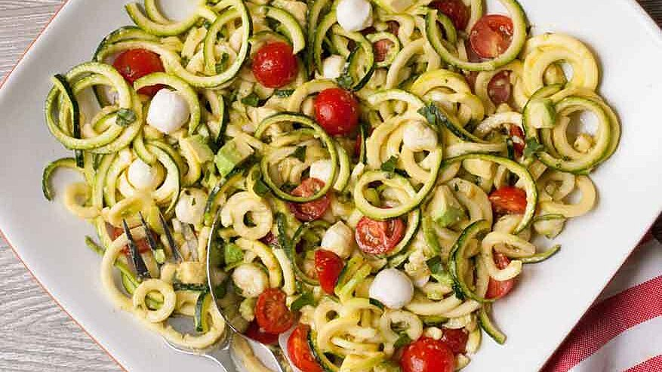

**Ingredients**

Ingredient Checklist

* ¼ cup extra-virgin olive oil
* 2 tablespoons white balsamic vinegar
* 1 tablespoon chopped fresh basil, plus more for garnish
* ¼ teaspoon garlic powder
* ¼ teaspoon salt
* ¼ teaspoon ground pepper
* 1 large zucchini
* 1 firm ripe avocado, cubed
* 1 cup halved cherry tomatoes
* ½ cup pearl-size fresh mozzarella balls

**Directions**

Instructions Checklist

* **Step 1**
* Whisk oil, vinegar, basil, garlic powder, salt and pepper in a large bowl.
* **Step 2**

Using a spiral vegetable slicer with the chipper blade attachment (for thick noodles), cut zucchini lengthwise into "noodles," stopping when you reach the seeds.

* **Step 3**

Add the zucchini noodles, avocado, tomatoes and mozzarella to the dressing and toss to coat. Serve topped with more basil, if desired.

**Tips**

**Equipment: Spiral vegetable slicer with chipper blade attachment**

**Nutrition Facts**

**Serving Size: 1 Cup**

**Per Serving:**

**192 calories; protein 4.1g; carbohydrates 6.5g; dietary fiber 3g; sugars 2.8g; fat 17g; saturated fat 3.6g; cholesterol 10.1mg; vitamin a iu 478.4IU; vitamin c 16.3mg; folate 44mcg; calcium 93.7mg; iron 0.5mg; magnesium 23.2mg; potassium 369.1mg; sodium 149.1mg.**

**Exchanges:**3 Fat, 1/2 Medium-Fat Protein, 1/2 Vegetable

<https://www.eatingwell.com/recipe/257779/tomato-basil-zoodle-salad/>